
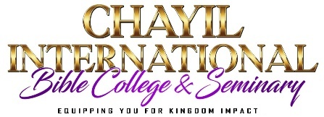

LETTER OF RECOMMENDATION FROM CHURCH PASTOR
Name of Applicant:
Name of Referral:

Your information about the applicant’s life will help us select men and women who are truly committed to working for the Lord. Please take time with prayer and supply the information requested below as fully and accurately as possible. Thank you for your cooperation.

- How long have you known the applicant?
- In what capacity have you known him/her? (Employer, Pastor, Teacher, etc. If relative, state the relationship)
- State in brief about the applicant’s personal commitment to Christ.
- In what ways is the applicant involved in the life and work of his/her local congregation?
- What gift has the applicant shown that could be useful in Christian service?
- All people have weaknesses. What do you feel are the main areas of weakness in the applicant’s life?
- To your knowledge, does the applicant: smoke/drink/use narcotics?
- Please check one:
I recommend the applicant very highly ( )
I recommend the applicant ( )
I recommend the applicant with some hesitation ( )
I do not recommend the applicant ( )

Church Information:

Referral Signature____________________________________________________ Date ______________________

Church Name ________________________________________________ Position/Title ______________________

City ____________________________________ State____________________ Phone _______________________

PLEASE DO NOT SEND THROUGH THE APPLICANT.
Please email the form to ChayilBibleCollege@TheChowChurch.org

