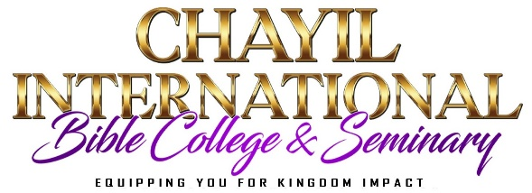

SPONSOR FINANCIAL GUARANTEE
Dear Sponsor: Please review the Seminary Fee structure before you fill out this form.

Candidate Name (Clearly Print) __________________________________________________________________________

Please select one: ( ) 20-month PFB Systematic New Testament Bible Study Certificate
( ) 12-month Ordination/Licensing Training Program Certificate

I/We undertake to pay the full fees for the candidate to be enrolled in the above-selected course: $___________________
I/We will be responsible for paying for the textbooks needed as well. ( ) Yes ( ) No

- List the total Certificate fees required by the Seminary: $ ___________________
- Sponsor will pay: ( ) Full payment ( ) Payment Plan
- I hereby undertake to support the above student for the entire period of study at Chayil International Bible College & Seminary by arranging to transfer either in full or installments as per the provision made in the rules, on or before the specified dates.

Date _____________________

Sponsor’s Name (Clearly Print) _____________________________________ Sponsor’s Signature _______________________
Full Address _________________________________________ City _______________________________ State ______________
Phone ( ) ________________________________________ Email __________________________________________________
( ) I understand that if the candidate withdraws for any reason, all fees are non-refundable.

